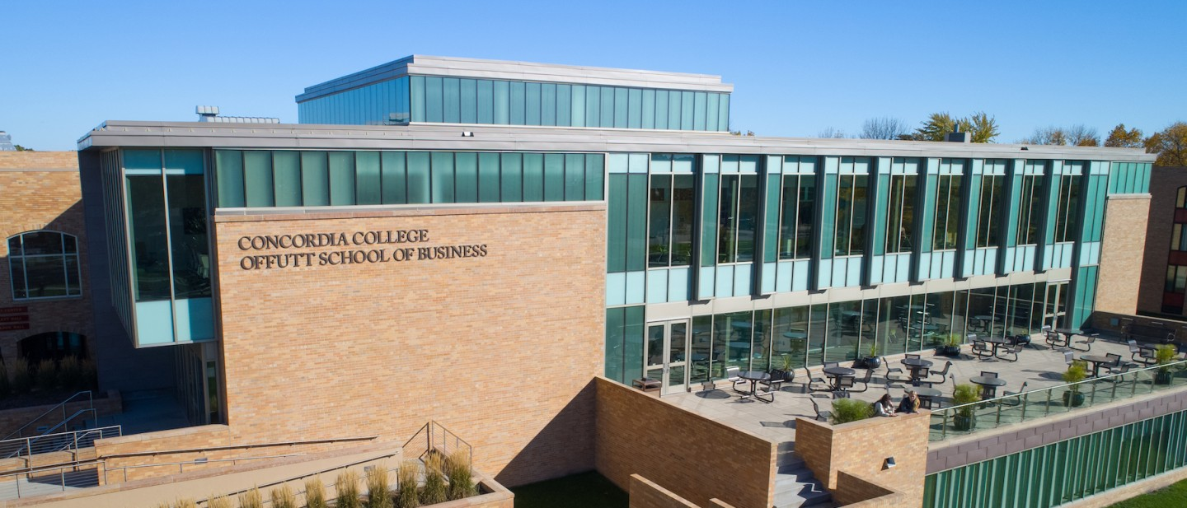

Project Plan

|  |
| --- |
| Cobber RPG |

|  |  |
| --- | --- |
| Course | **CSC 225 – Fundamental Structures** |
|  | |
| Team Name | **Office Heroes** |
|  |  |
| Team Members | **Jaleta Fanta Tesgera** |
|  | **Segni Tadele Tulu** |
|  | **Ye Yint Win** |

|  |
| --- |
| Executive Summary |
| Your executive summary should resemble an elevator pitch: your motivation is to quickly persuade a decision maker to get involved in your project.  What is the purpose of your project? What problem(s) does it address?  To know more about Concordia College through a game. Students don’t know a lot about the buildings of the college as they only have to attend classes in some of the buildings and incoming students as well due to the weather and COVID restrictions.  Why is your project important? Why is it relevant?   * Due to covid, freshmen students are not getting the full in-person experience of Concordia campus. * It can help assist incoming students and faculties to get to know more about Concordia. * It can help new ambassadors to know more about Concordia and put their knowledge to the test(game). * It can serve as a base for anyone who wants to know more about Concordia. |

|  |
| --- |
| Timeline |

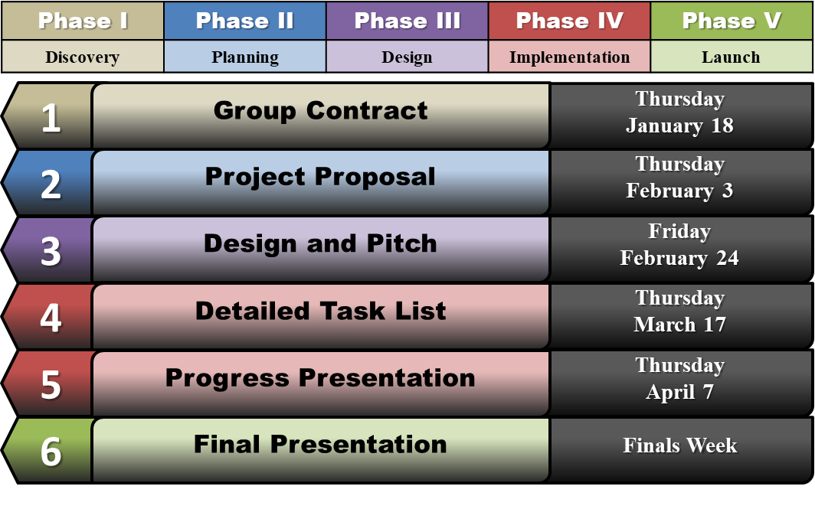

|  |  |  |
| --- | --- | --- |
| Milestone Summary | | |
| **Milestone 1** | **Group Contract** |  |
| **Item** | **Description** | **Date Completed** |
| **Purpose** | **Create a final project team** | **01/20/2022** |
| **Summary** | Self-organize into groups of 3-4 students for working together on the semester project.  All team members will need to complete the group contract and agree to its terms, holding each other accountable for contributing to the final project throughout the semester. | 01/20/2022 |
| **Task M1A – Team Member Names** | List all team members with full (first and last) names on the group contract document | 01/20/2022 |
| **Task M1B – Office Heroes** | Come up with a name for the group/team to be addressed as during presentations; list the name on the group contract document | 01/20/2022 |
| **Task M1C – Weekly Meeting Time** | Block off an hour of time once per week when all team members could regularly meet as necessary throughout the semester; list the time in the group contract document | 01/20/2022 |
| **Task M1D – Signatures** | Each team member signs the group contract document (this may be a digital signature or initials) | 01/20/2022 |
| **Task M1E – Planning Document** | Complete the cover page of the planning document, fill in the date each milestone task was completed in the milestone summary, and detail the additional milestone activities in the Milestone Summary section (insert new rows into the table). | 01/20/2022 |
| **Milestone 2** | **Project Proposal** |  |
| **Item** | **Description** | **Date Completed** |
| **Purpose** | **Determine final project topic** | **01/02/2022** |
| **Summary** | As a group, choose a topic all team members want to work on; discuss potential ideas and come to a group consensus what your project will be and why it is important. | 01/02/2022 |
| **Task M2A – Project Proposal Document** | Complete the project proposal document | 03/02/2022 |
| **Task M2B – Presentation** | Present the project proposal to the class | 03/02/2022 |
| **Task M2C – Planning Document** | Complete the executive summary section of the planning document, fill in the date each milestone task was completed in the milestone summary, and detail the additional milestone activities in the Milestone Summary section (insert new rows into the table). | 01/02/2022 |
| **Milestone 3** | **Design and Pitch** |  |
| **Item** | **Description** | **Date Completed** |
| **Purpose** | **Create a general look-and-feel for your project, present your project to the class** | **02/22/2022** |
| **Summary** | Determine how you want your final project deliverables to look, including color scheme, graphics/images, and placement and layout of major components (e.g. buttons, input fields, data, instructions, etc.).  Armed with your project proposal and design mockups, show the class what you plan to accomplish with your project. Think of the class as potential investors or contributors; why should they care about your project? | 02/23/2022 |
| **Task M3A – Major Components** | Create a list of major components that will be included in your project (e.g. input/output, images, instructions, etc.) | 02/22/2022 |
| **Task M3B – Color Scheme** | Create a color scheme for your project for a consistent design | 02/23/2022 |
| **Task M3C – Design Mockups** | Create design mockups (use lorem ipsum filler text, at least basic boxes/shapes if not actual design) to show the planned layout of project deliverables, including any major pages/screens that will be included in the final project | 02/23/2022 |
| **Task M3D – Presentation** | Pitch the project to the class | 02/24/2022 |
| **Task M3E – Planning Document** | Include screenshots of all design mockups, list of components (labeled for easy identification), screenshots of the project pitch presentation, fill in the date each milestone task was completed in the milestone summary, and detail the additional milestone activities in the Milestone Summary section (insert new rows into the table). | 02/23/2022 |
| **Milestone 4** | **Detailed Task List** |  |
| **Item** | **Description** | **Date Completed** |
| **Purpose** | **Plan the remaining tasks required to complete the project** | **03/14/2022** |
| **Summary** | As a team, figure out what needs to happen in order to take the project from its current design and planning stage through implementation to completion.  Break down each major component of the project to estimate how much work you think it will take to complete, and what detailed tasks/actions will need to be performed for each. | 03/14/2022 |
| **Task M4A – Gantt Chart** | Create a Gantt chart showing a detailed task breakdown with expected due dates and assigned team members | 03/16/2022 |
| **Task M4B – Presentation** | Present your Gantt chart and task list to the class | 03/16/2022 |
| **Task M4C – Planning Document** | Include a screenshot of the Gantt chart, fill in the date each milestone task was completed in the milestone summary, and detail the additional milestone activities in the Milestone Summary section (insert new rows into the table). | 03/16/2022 |
| **Milestone 5** | **Progress Presentation** |  |
| **Item** | **Description** | **Date Completed** |
| **Purpose** | **Provide the class with a project status update** |  |
| **Summary** | Show the class (client) what work has been completed toward the final project deliverables. |  |
| **Task M5A – Presentation** | Present your work progress to the class |  |
| **Task M5B – Planning Document** | Include screenshots of your presentation, fill in the date each milestone task was completed in the milestone summary, and detail the additional milestone activities in the Milestone Summary section (insert new rows into the table). |  |
| **Milestone 6** | **Final Presentation** |  |
| **Item** | **Description** | **Date Completed** |
| **Purpose** | **Show your completed project to the class** |  |
| **Summary** | Share your hard work over the course of the semester with the class. |  |
| **Task M6A – Presentation** | Present your completed project to the class |  |
| **Task M6B – Planning Document** | Include screenshots of your final project deliverables and presentation, fill in the date each milestone task was completed in the milestone summary, and detail the additional milestone activities in the Milestone Summary section (insert new rows into the table). |  |

|  |  |
| --- | --- |
| Resource List | |
| **Resource Name** | Concordia College |
| **URL** | <https://www.concordiacollege.edu/about/concordia-traditions/kernel-and-niblet/> |
| **Date Accessed** | **Feb-23-2022** |
| **Notes** | *Kernel and Niblet*. (2007, October 4). We will use them as a character. |
| **Resource Name** | Adobe |
| **URL** | <https://www.adobe.com/express/feature/image/transparent-background> |
| **Date Accessed** | **Feb-22-2022** |
| **Notes** | Free Transparent Background Maker- we will use the transparent as a background and other purposes too. |
| **Resource Name** | Yahoo Sports |
| **URL** | <https://sports.yahoo.com/ncaaf/teams/concordia-(ala)/?guccounter=1&guce_referrer=aHR0cHM6Ly93d3cuZ29vZ2xlLmNvbS8&guce_referrer_sig=AQAAAJ5NBvksqnFqk9aK5RMiyRcOPUZcUxBHo7bEoWnYnDutackcKmkg1lu_IBaWT99VyKcpZW7lnhjm8jikjn8I4qFFx_M3hsB0cZcP9tkKSASZwjH2LcWxHHJh4Mom1dM_XKC-m-qvFja8VznJ5VEBAXZC5IzkrA-pFb_7NLaRChqz> |
| **Date Accessed** | **Feb-23-2022** |
| **Notes** | We used this website to take a better picture of Niblet and some style for the background page. |
| **Resource Name** | Facebook |
| **URL** | <https://www.facebook.com/unsupportedbrowser?_rdr> |
| **Date Accessed** | **Feb-22-2022** |
| **Notes** | We used this website again for a picture of Niblet and Kernel. |
| **Resource Name** | Concordia College |
| **URL** | <https://www.concordiacollege.edu/about/now/> |
| **Date Accessed** | **Feb-23-2022** |
| **Notes** | We used this webpage to see how they used the college logo and how what kind of backgrounds they used in the back and the color combined. |
| **Resource Name** | Cobber Net |
| **URL** | |  | | --- | | <https://bprdeis.cord.edu:8443/authenticationendpoint/login.do?commonAuthCallerPath=%252Fcas%252Flogin&forceAuth=false&passiveAuth=false&tenantDomain=carbon.super&sessionDataKey=139abc2a-43ec-4c95-8a13-271a1238e7c2&relyingParty=cobbernet&type=cassso&sp=cobbernet&isSaaSApp=false&authenticators=BasicAuthenticator:LOCAL> | |
| **Date Accessed** | **Feb-19-2022** |
| **Notes** | Like some web pages, we used this webpage to find some pictures of Kernel and background only for the login page. |